|  |
| --- |
| **Request for Academic**  **Records/Transcripts** |

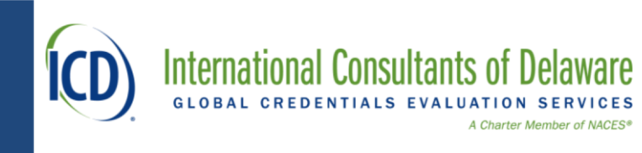

International Consultants of Delaware • Philadelphia, Pennsylvania, USA • www.icdeval.com

National Certification Commission for Acupuncture and Oriental Medicine (NCCAOM)

Credential Assessment

Applicant completes this section. (Send one form to each school you have attended. Do not sent without ICD file number.)

Student’s Current Name:

Name When Attended

School (If Different):

Other Names:

Name of School:

Dates of Attendance: to Birth Date:

Email: Telephone：

Mailing Address:

Student’s Signature: Date:

ICD File Number:

**School Certification Officer：**

1. Complete all the questions on this form.
2. Complete the student’s attached Oriental Medicine Course Classification Form listing the courses taken, grades earned, theory and laboratory hours, and clinical practice hours.
3. Complete the student’s attached Oriental Medicine Course Descriptions, and follow the example fill in.
4. Put this document and attached in a sealed envelope, The seal covers the school or the official seal of the Academic Affairs Office.
5. Send by airmail (traceable) to China Health, Address: 9/F, Building B2, Ziguang Development Building, No. 11 Huixin East Street, Chaoyang District, Beijing, China

(NOTE: China Health is authorized to forward documents to International Consultants of Delaware)

If you need assistance, please contact

ICD at (215) 243-5858 Monday through Friday from 12:30 to 3:30 p.m. ET USA.

China Health at (86) 134-2620-0518 Monday through Friday from 9:00 to 18:00 p.m. Beijing

Student’s Birth Date:

Student’s Name When Attended: Month Day Year

School Name When Student Attended:

Current School or Authority Name Where Academic Records / Transcripts Reside (If Different Name):

Current School Address: Street Address P.O. Box (Optional)

Current School Address: City State / Province Postal Code Country

Current School Telephone: Current School Fax:

Current School Contact Email: Current School Web Address:

Language in which Student Was Instructed: Textbook Language of Student’s Program/Course of Study:

Course of Study Name of Diploma/Degree Obtained in Original Language:

Program Type (Circle One):

Diploma Certificate Associates Bachelors Baccalaureate Masters Doctorate Other

Attendance Dates: Did the Student Complete the Program?

Month Year Month Year (Circle One):

To

Yes – Completed

No –Did Not Complete

Was the School Accredited by Government Approved When

Student Completed the Courses or Graduated? (Circle One): If Yes, Name of Organization Accrediting or Approving School:

YES NO

Date School Accredited or Approved: Month Day Year

Was the Educational Program Accredited or Government

Approving the Approved When Student Completed the If Yes, Name Organization Accrediting or

Courses or Graduated? (Circle One): Educational Program:

YES NO

Date Educational Program Accredited or Approved: Month Day Year

**I hereby attest that the enclosed academic records/transcripts accurately state the courses taken by the student including hours of study, course descriptions, grades and clinical practice received. Please sign below and then PLACE YOUR SEALBELOW.。**

Registrar Signature: Month Day Year

Print Name: Title:

Registrar Email Address: